1) question

- The generator's role is to generate the data (images, gif in this week lab,etc…..) that mimics the real data distribution. It takes random noise (often a vector of random values) as input and produces data as output. The goal of the generator is to generate data that good enough to make the discriminator thinks the generated data is real.

- The discriminator's job is to distinguish between real data (dataset) and generated data from the the generator.

2) meddling with latent space

Latent_dim = 512 -> 1024

Interploate between v1 and 2 go form 25 to 50

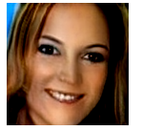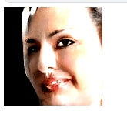

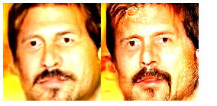

Base:

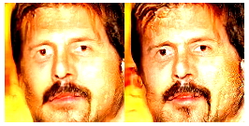

Overall the results seems to be a little less bright, mustache and beard barely connect and less hair detail as well . I wasn’t able to capture the gif since it move so fast

3) Generated art (AnimeGAN on github: <https://github.com/soham2707/AnimeGAN/blob/master/AnimeGAN.ipynb>)

https://www.kaggle.com/code/binhswinburnehn/notebooka8001e06e4

